**CHAPTER 1**

**PROJECT DEFINITION**

* 1. **INTRODUCTION**

Furniture Shop now stands on it’s 36th year with two stores found in Bacoor and Silang, Cavite. The shop offers high quality furniture that goes from simple and classic to one very luxurious design.

The business is owned and managed by a family, but mostly by the parents who still list and writes the orders made per day and the receipts and bill per transaction. It’s difficult processing the transaction due to the unorganized stack of charts and voluminous brochures. The shop also uses the forms improperly which leads to difficult retrieval of order records.

The proponents aim to provide a Web-Based Management system entitled, Furniture Shop Management System. This system will help the family in making faster transactions.

It will help them in storing and retrieving information, enhancing the security of their records. The customers will also find it more convenient to choose a furniture by sending their desired design with the customization feature. With this system, the furniture shop that is running for 36 years now, will keep up with the rapidly changing society and developing technology.

* 1. **BUSINESS CASE**
     1. **BACKGROUND OF THE ORGANIZATION**

Furniture Shop makes high quality furniture made of narra wood with designs that goes from simple and classic to a very luxurious one. They offer furniture generously made of narra and of high quality fabrics imported from other countries. The shop creates furniture for display and for walk-in customers to see and purchase. They accept orders with designs picked from their brochures or customized designs specified or brought by the customer.

The 36 year old running business now has two stores; both stores are managed by the family members themselves. Josephine Bonayon Baraquiel, one of the owners, proposed the idea of making furniture shop to her husband because she herself is a daughter of a furniture maker. Josephine used to help her parents way back when she was in their care. Her parents influenced her in every way and together with her husband they build the Furniture shop together.

This business is the reason they got to where they are now, from a small shop at vicinity in Albay, Bicol to owning two stores located nearby the capital city of the country. The Furniture Shop is also the reason how they manage to send their six children to decent universities and now their children are working at great companies and is helping them from time to time.

The Furniture shop’s number one priority in furniture making is ensuring that the furniture they make is of high quality and can be considered world class. They also wanted to join the bandwagon of online shops in the country to be part of this rapidly changing society.

* + 1. **PROJECT OVERVIEW**

The project aims to help the said Furniture Shop in making their transactions faster, easier and help them keep pace with the rapidly changing society by providing them a web-based system. This web-based system will have a website and an admin interface. The admin interface is where the manager can update their featured furniture, add and remove furniture and manage orders made personally or through the website. The website will display all furniture the shop can offer. The customer can easily order furniture just by browsing through the website and the manager will find it easy to manage orders and produce the customers’ bills and receipts.

It will also help the customers choose design on their perspective by sending their own design in our customization feature. With the system the manager can easily store and retrieve information, thus minimizing the time for looking upon the client’s record every time they deliver.

* + 1. **PROJECT CONSTRAINTS**

The constraints considered by the proponents are the following:

* Time frame given for the project is 10 months, limited amount of time to build the system.
* The scope of the project covers maintainance and transaction processes of the business.
* The proponents are currently students with limited source of income. It is certain that they cannot invest financially.

.

* + 1. **PROJECT ASSUMPTIONS**
* **The Project will be finished on time**

The fully-functional system project will be finished on time with no errors and bugs.

* **The project team will able to acquire all the information and documents needed**

The client will be able to provide all necessary documents and information for the Project Team to comply with the requirements of the project and be able to provide them a running system that functions accurately.

* **User Acceptance**

The client will be satisfied with the final outcome of the project. The project will lighten the works of the users, their transaction will be faster and provide a better service to their customers.

**1.3. SCOPE AND LIMITATION**

The project focuses on processes of the furniture shop which includes order management, billing and collections and production tracking.

Transaction includes point of sales, raw materials management, delivery tracking and production management. The system will also have a feature of customization which allows the customers to send their own design of the furniture. Maintenance of the fields needed for the transactions will be covered. The system also produces queries and reports.

The system will not cover full inventory transaction of raw materials of the business.

**1.4. METHODS USED IN THE STUDY**

**1.4.1 Data Gathering Techniques**

* **Observation**

The proponents observed the business environment and how they do things thus making it easier for us to know their problems.

* **Personal Interview**

The proponents conducted an interview to gather data needed for this project. This serves as the way to obtain useful information to the people who know the business very well.

* **Document Analysis**

The forms we gathered will be analyzed to understand the business and know what data are needed for the transactions.

**1.4.2 Software Process Model**

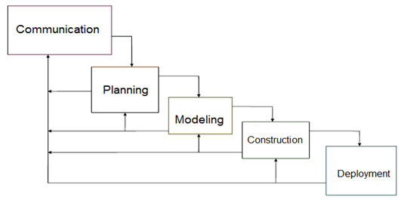

**Figure 1.4.2. Waterfall Model with Feedback**

The team used the Waterfall Model with Feedback as a model used in visualizing the step by step process the group is going to take to finish the project on the scheduled time. The Waterfall Model with Feedback is a simple and easy to use model because of it’s rigidity. Each phases has a specific deliverable and a review process therefore after making progress on the project we can go back to the client and ask if what we produce is accurate according to their business rules and processes.

**CHAPTER 2**

**FUNCTIONAL SPECIFICATION REPORT**

**2.1 DATA REQUIREMENTS**

**2.1.1 FORMS**

**2.1.1.1 LIST OF FORMS**

|  |  |  |  |
| --- | --- | --- | --- |
| **Form #** | **Form Name** | **Description** | **User** |
| F1 | Sales Invoice | This contains the customer information, order information, order specification and payment information. This serves as the contract and the bill. | Manager, Customer |
| F2 | Job Order | This contains the details of the ordered furniture the manufacturer should follow. | Manager, Manufacturer |
| F3 | Delivery Receipt | It contains delivery information, order information and payment information. This is given to the delivery man and later on passed to the customer as final receipt. | Manager, Customer, Delivery Man, |
| F4 | Official Receipt | This contains the payment details of the customer. This is given to the customer every payment made. | Manager, Customer |

***Table 2.1 List of Forms***

**2.1.1.2 SAMPLE OF FORMS**

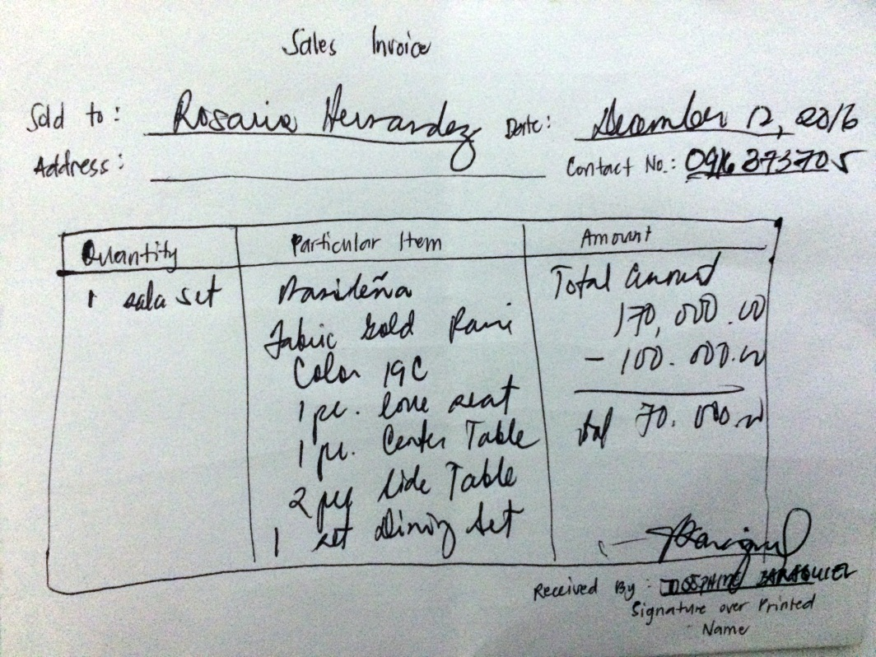

***Figure 2.1 Sample Sales Invoice Format***

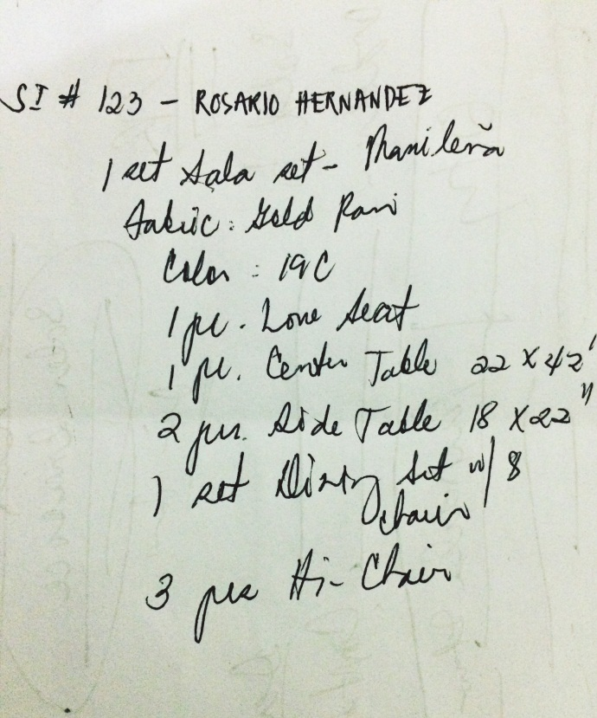

**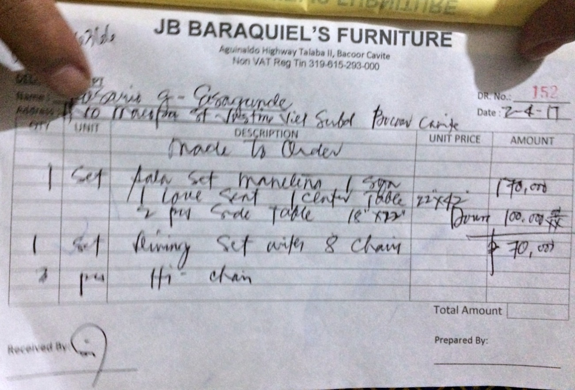*Figure 2.2 Sample Job Order Format***

***Figure 2.3 Sample Delivery Receipt***

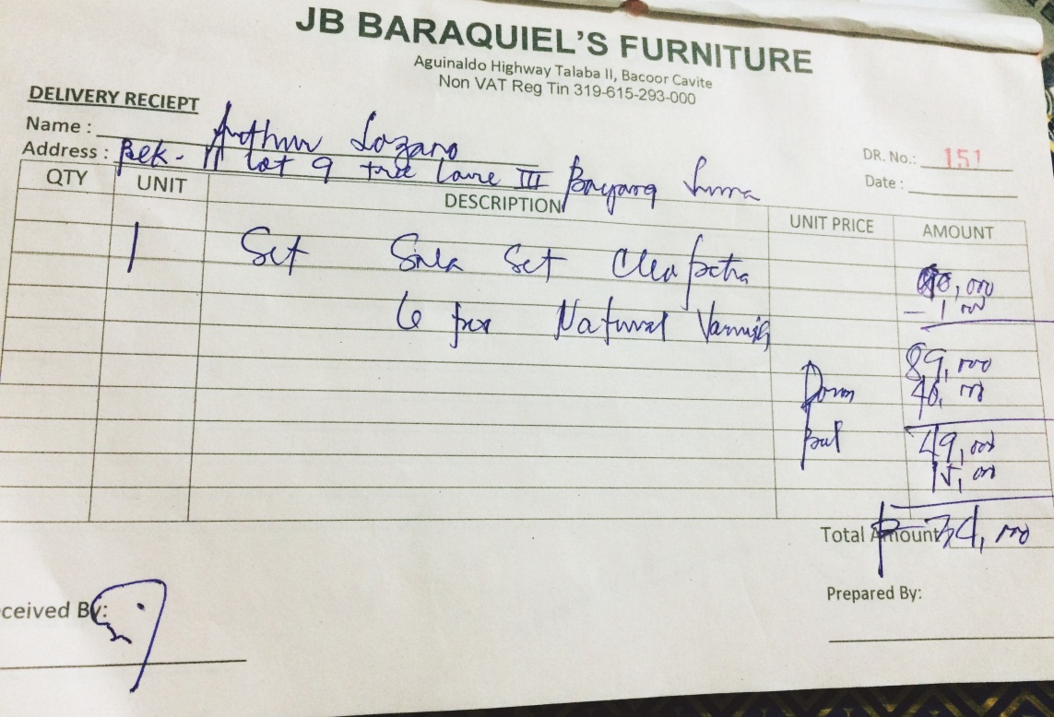

***Figure 2.3.1 Sample Delivery Receipt***

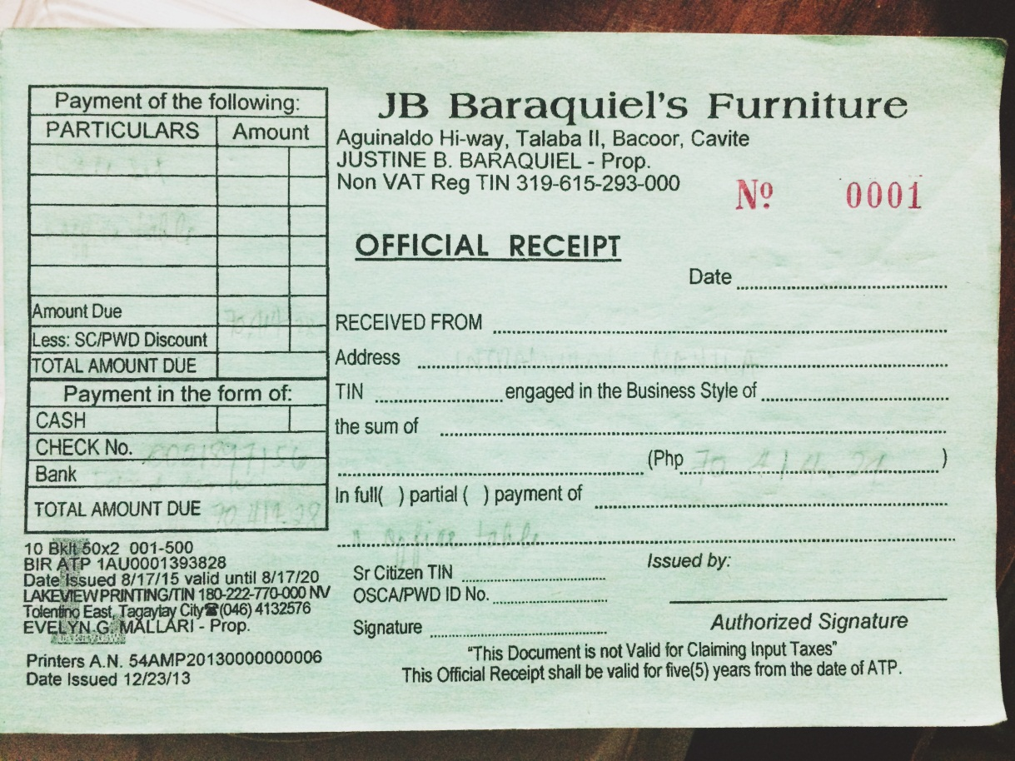

***Figure 2.4 Sample Official Receipt***

**2.1.2 REPORTS**

**2.1.2.1 LIST OF REPORTS**

|  |  |  |  |
| --- | --- | --- | --- |
| **Report #** | **Report Name** | **Description** | **Frequency** |
| R1 | Sales Report | Contains the daily record of the furniture sold to customers. | Daily, Monthly, Annually |

***Table 2.1.2 List of Reports***

**2.1.2.2 SAMPLE REPORTS**

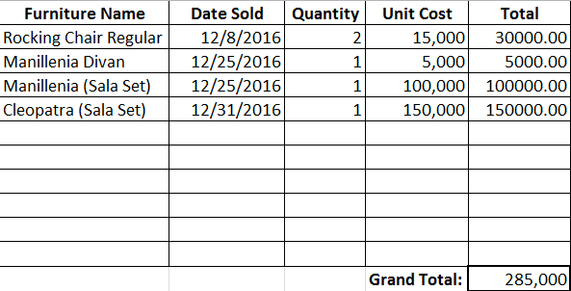

***Figure 2.5 Sample Sales Report Format***

**2.2 POLICIES AND PROCEDURES**

**2.2.1 PROCEDURES**

**2.2.1.1 CONTEXT DIAGRAM**

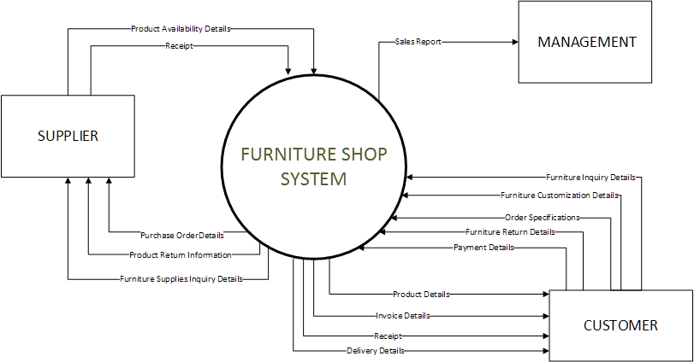

***Figure 2.6 Context Diagram***

**2.2.1.2 LEVEL 1 DFD**

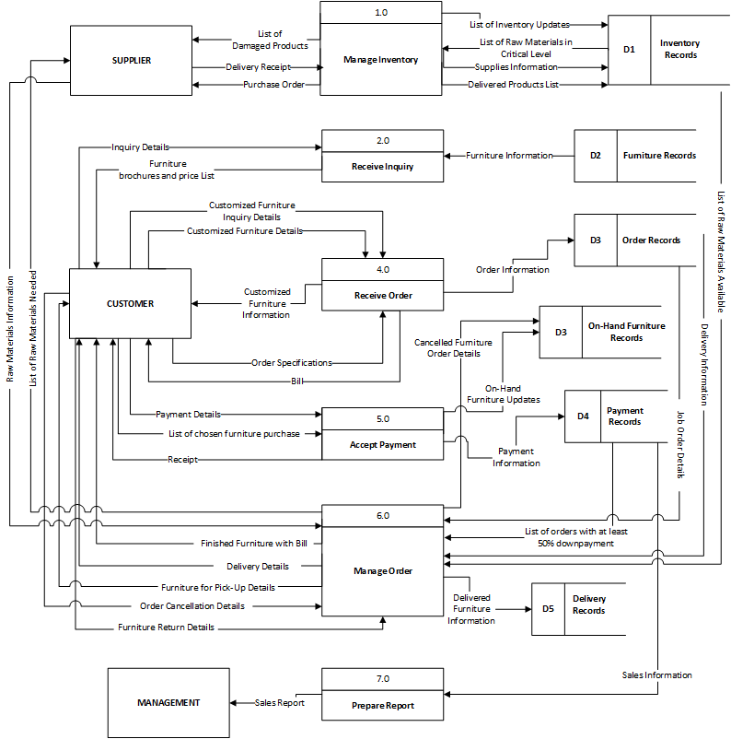

***Figure 2.7 Level 1 Data Flow Diagram***

**2.2.2 POLICIES**

**2.2.2.1 BUSINESS REQUIREMENTS**

|  |  |
| --- | --- |
| **BR NO.** | **BUSINESS REQUIREMENT** |
| **BR001** | The production of furniture will begin once the customer paid a down payment of at least 50% of the total amount of the ordered furniture. |
| **BR002** | A storage fee of PHP 500 pesos will be added to the total balance if furniture is not claimed or is fully paid on or before the day the contract will end. |
| **BR003** | A detailed description and specification is needed for customized furniture. |
| **BR004** | Damage on furniture caused by natural disaster and by improper use or maintenance is not covered on the warranty. |
| **BR006** | Official receipt must be presented to acquire warranty. |

***Table 2.2.2.1 Business Requirement***

**2.2.2.2 BUSINESS POLICIES**

|  |  |
| --- | --- |
| **BP NO.** | **BUSINESS POLICIES** |
| **BP01** | The customer must pay at least 50% of the total price of the furniture ordered for the production of furniture to begin. |
| **BP02** | On-hand furniture must be fully paid upon acquisition. |
| **BP03** | Furniture must be claimed, paid or delivered on or before the end of the contract. |
| **BP04** | If a customer cancelled his/her order the down payment will be given back deducting the storage fee once the furniture has been sold. |
| **BP05** | If ordered furniture is not claimed within 1 month (30 days) and 1 week after the contract’s expiration the management has the right to resell the furniture. |
| **BP06** | The price of a customized furniture will be decided by the management |
| **BP07** | The furniture will be replaced or repaired if found broken upon delivery. |
| **BP08** | Six months warranty is given to all furniture. |

***Table 2.2.2.2 Business Policies***

**2.3 PROBLEM ANALYSIS**

**2.3.1 FISHBONE**

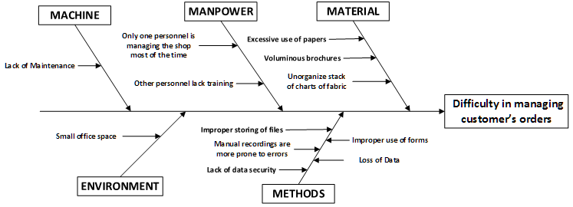

***Figure 2.6 Fishbone Diagram of the Furniture Shop***

**2.3.2 PROBLEMS AND REQUIREMENTS**

|  |  |  |  |
| --- | --- | --- | --- |
| **Ref. Page** | **No.** | **Problem** | **Requirements** |
| 16 | 1 | Lack of Maintenance. |  |
| 16 | 2 | Only one personnel is managing the shop most of the time. |  |
| 16 | 3 | Other personnel lacks training. |  |
| 16 | 4 | Improper storing of files. |  |
| 16 | 5 | Manual recordings are prone to errors. | Automation of recordings. |
| 16 | 6 | Lack of data security. |  |
| 16 | 7 | Excessive use of papers. |  |
| 16 | 8 | Voluminous brochures. |  |
| 16 | 9 | Unorganized stack of charts of fabrics. |  |
| 16 | 10 | Improper use of forms. |  |
| 16 | 11 | Loss of data. |  |